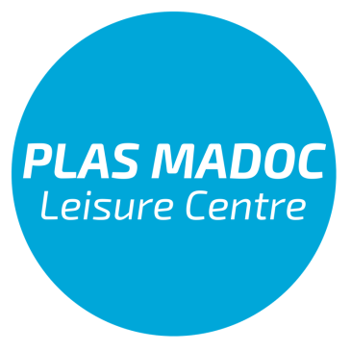

Job Description for Receptionist

Purpose:
To serve customers at Reception, managing all administrative aspects and functions of the Reception department at Plas Madoc Leisure Centre. Overseeing all general office administration tasks, managing the day to day office environment, managing block bookings.

Reports to: Sales, Marketing & Admin Officer

Responsible for: n/a

Salary: minimum wage

Key responsibilities:
Operational and administration
- To work shifts on Reception, answering telephone calls, transferring calls to relevant colleagues and taking messages where appropriate.
- To manage all pay as you go bookings and payments for activities taking place in the Centre.
- Be accurate when handling cash and have excellent attention to detail.
- To respond to or forward Plas Madoc Leisure Centre emails from members of the public, clients, associated organisations and suppliers in accordance with instructions.
- To field enquiries for block bookings, placing bookings and maintaining a waiting list, maximising the usage of all facilities at all times.
- Confirm all block bookings and one-off event bookings in writing. Coordinating the relevant information to the relevant departments.
- To keep and maintain records of block bookings payments and chase outstanding payments.
- To support the maintenance of the membership scheme, processing new members and managing the administration of the membership forms, including the maintenance of the direct debit system.
- To attend meetings as required.
- To support your line Manager in the administration of all events and tournaments.
- To maintain good working relationships with outside agencies and the general public in order to uphold the Centre’s image.
Special conditions
- To carry out such duties as may be determined by the Senior Management team.
General responsibilities:
- To maintain the highest standard of professional conduct at all times with customers, colleagues, stakeholders and the general public, both at work and socially.
- To make a contribution to sharing ideas, knowledge and best practice to ensure the long term success of Plas Madoc Leisure Centre.
- To adhere to employment policies as detailed in the Employee Handbook.
- To follow all health & safety procedures in order to ensure the safety of you, colleagues, customers and others who may be affected by your behaviour.
- To uphold Plas Madoc Leisure Centre’s commitment to equality of opportunity to all by following the Equality & Diversity Policy.
- To support Plas Madoc Leisure Centre in achieving its environmental aims and objectives.

Person Specification for Receptionist
Experience:
- Must be able to demonstrate administrative experience within a public or private sector organisation
- Must be able to demonstrate a clear understanding of customer needs.
- Should ideally be able to demonstrate experience of working within a busy leisure centre environment within the public or private sector.
- Should ideally be able to demonstrate a understanding of how a third sector organisation operates; be sympathetic to the aims of Splash Community Trust; and be sensitive to the political nature of the organisation

Qualifications or Training:
- Must have GCSE’s or equivalent including Maths and English
- Should ideally have relevant IT qualifications
- Should demonstrate evidence of Continuous Personal Development

Practical Skills:
- Must have strong organisational skills
- Must be able to communicate with a wide range of people effectively at all levels, both orally and in writing
- Must have excellent Information Technology skills
- Most be accurate

Personal Qualities & Attributes:
- Must be able to work unsupervised and to agreed outcomes
- Must have a thorough and accurate approach to all work with the ability to apply set procedures
- Must have a flexible and adaptive attitude to change and do everything to make new approaches and methods work
- Must be able to work in a busy environment
- Must be able to work as part of a team
- Must have an open, honest, approachable and pleasant, friendly personality
- Must be confident and professional
- Must ensure personal appearance is of the highest standard of tidiness and hygiene
- Must accept the importance of maintaining and improving standards and strive to exceed expectations at all times

