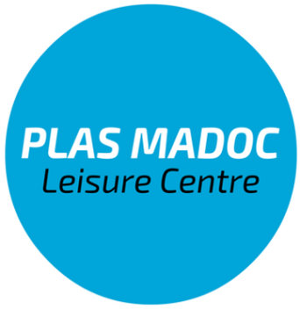
Plas Madoc Leisure Centre is looking to recruit 2 part time Gym Instructors
All applicants must hold a level 2 Gym Instructor Qualification
Hourly rate of pay is £7.10 per hour or minimum wage
You will be working evenings, weekends and bank holidays when required.
We are looking for an enthusiastic, motivated person who can work as part of a team and provide excellent customer service. We are looking to recruit an experienced person who can become a valuable member of our fitness team. Your duties will include supporting the Gym Supervisor in ensuring the efficient and effective operation of the gym, inductions, writing individual programmes and ensuring professionalism is maintained at all times.
You will be required to follow a 3 week rota pattern,
Post 1
week 1 – Monday 6.00-10.00pm
week 2 – Monday 6.00-10.00pm & Wednesday 5.00-10.00pm
Week 3 – Thursday 5.00-10.00pm & Sunday 9.00am – 5.00pm
Post 2
week 1 – Thursday 5.00-10.00pm
week 2 – Thursday 5.00-10.00pm & Sunday 9.00am-5.00pm
Week 3 – Monday 6.00-10.00pm & Wednesday 6.00 – 10.00pm

An application form is available from our website www.plas-madoc.com
The email address for submission of the application form is denise.chadwick@plas-madoc.com

Closing date for applications is Friday 14th February 2020
Interviews will be held on Monday 25th February 2020

